**Introduction of the project:-**

* This project is develop and used languages are HTML,Css, javascript & bootstrap .
* It’s consists of five navigation bars which are directed-open on the same page.
* Navigation bars:- home,menu,gallery,chief’s & contacts.
* While developing the web page we use bootstrap for develop more responsive web-page.
* Form page are redirected on the new page.
* When you have to press “LEARN MORE” then the new window open.

**Home page:-**

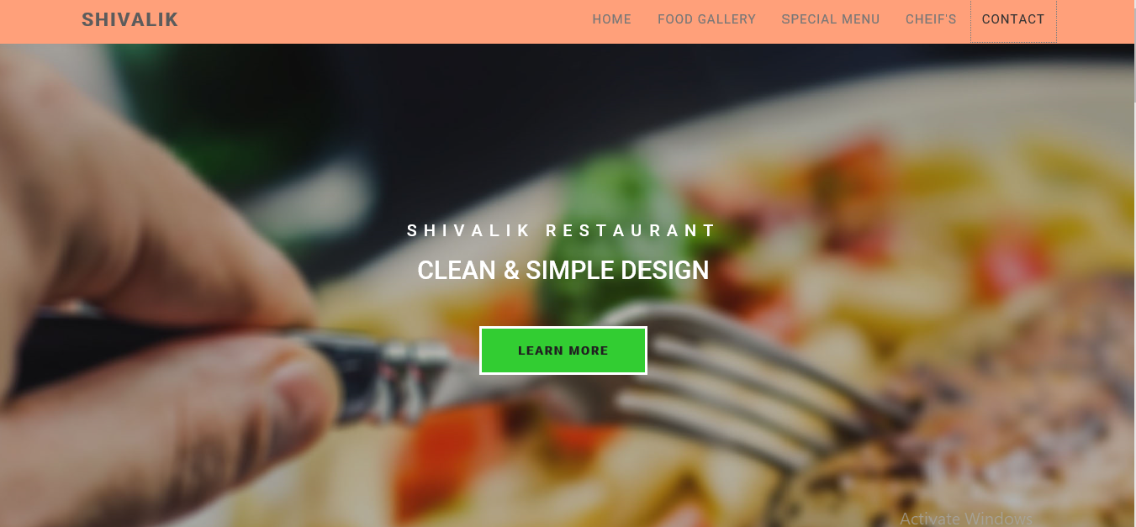

**After Clicking LEARN MORE OPTION:-**

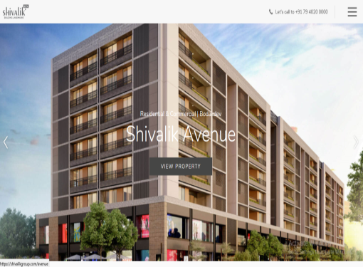 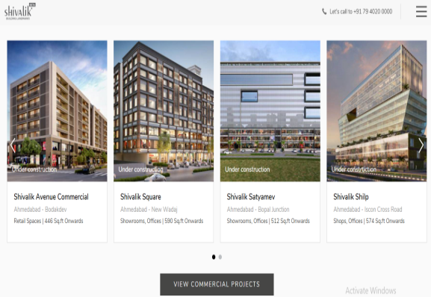



**Food page:-**

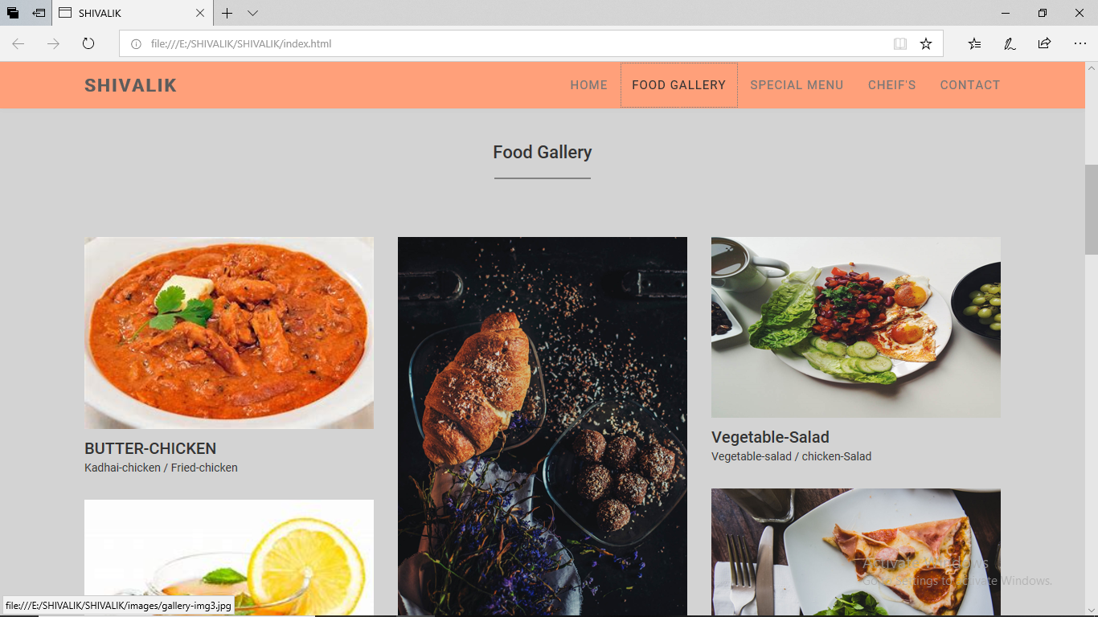

**Menu page:-**

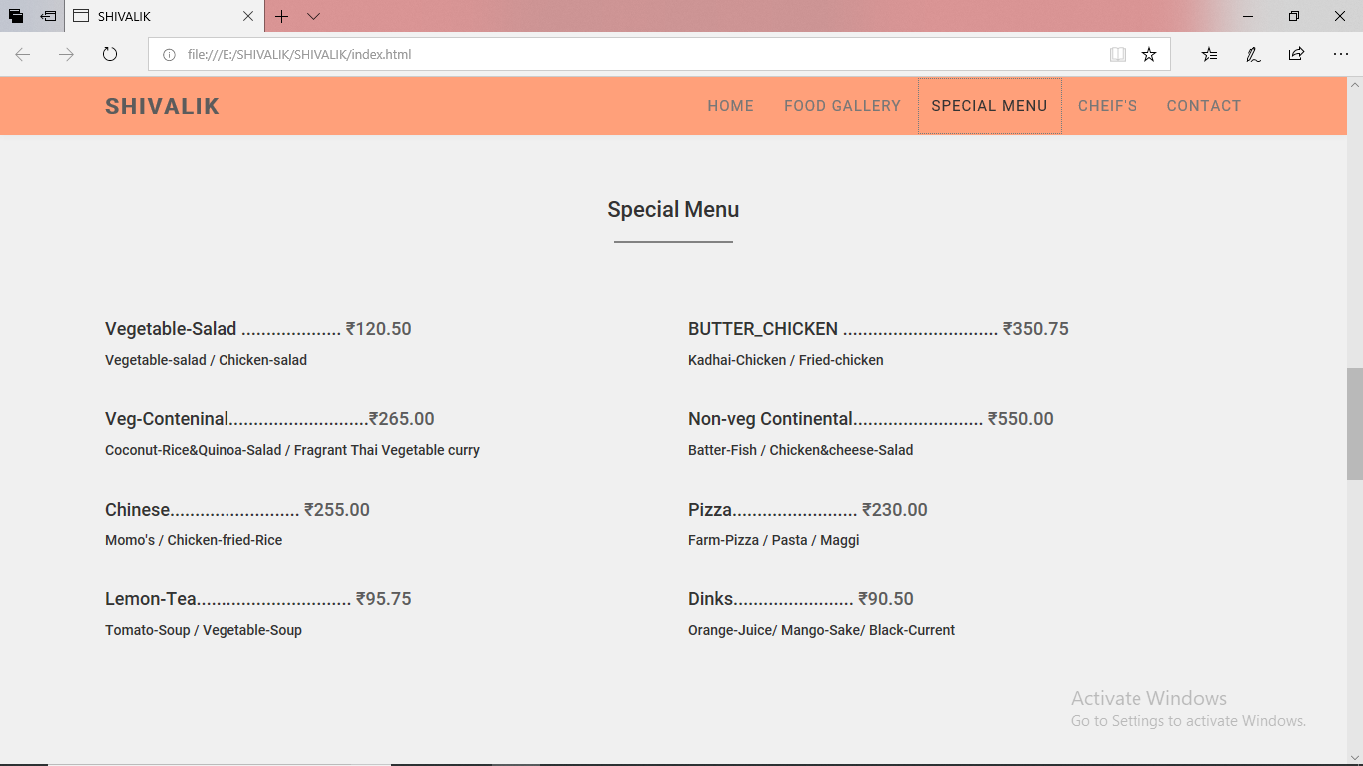

**Chief’s page:-**

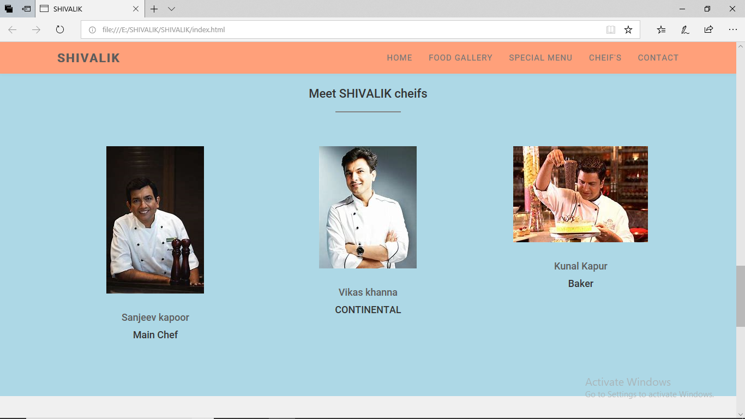

**Contact page:-**

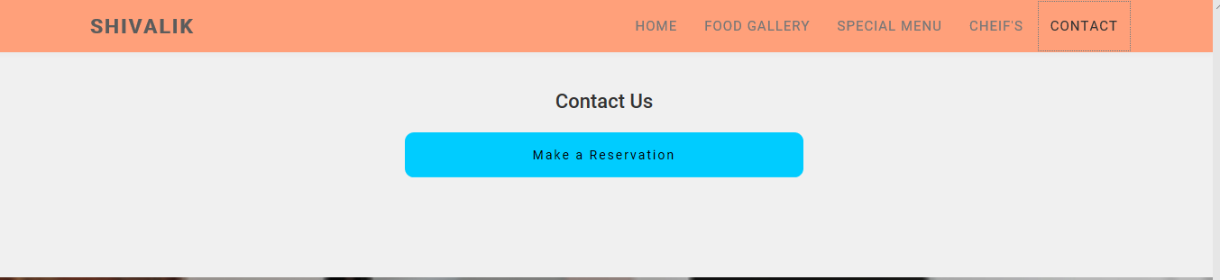

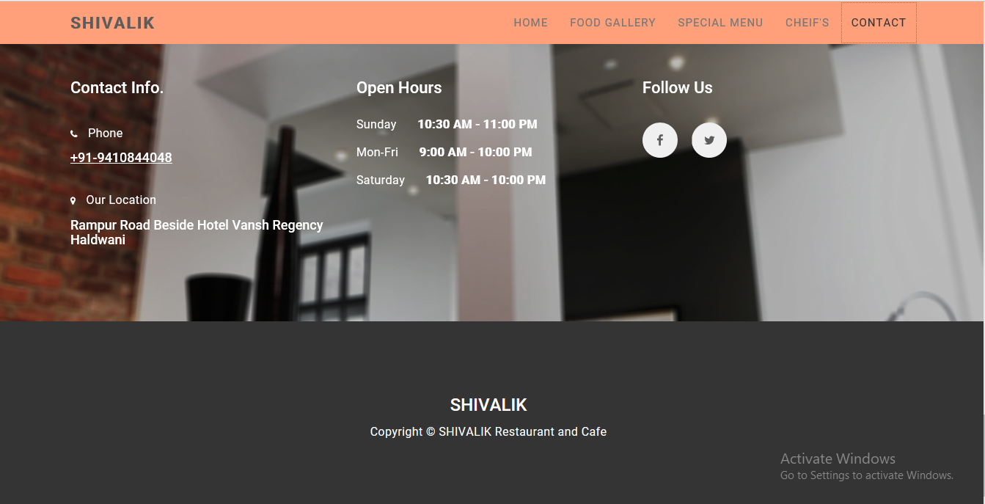

**Form page:-**

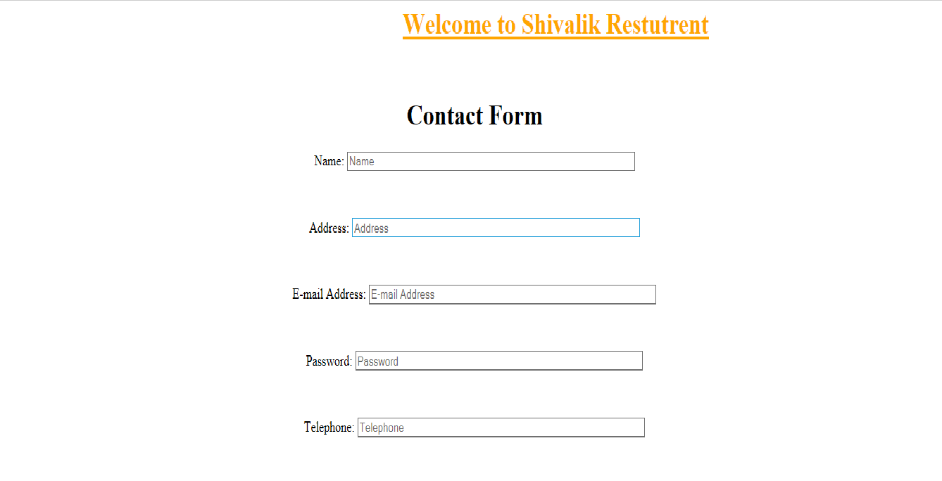



**DEVELOPED BY:-**

Suraj Singh & Vishal Poona

